OS Assignment # 2
Alina
261038589
Tania Sadaqat
261032455
Nawal Saqib
271064470

Theory:
A system call is the controlled entry point from user space into the kernel. As user programs cannot execute privileged CPU instructions or directly access hardware, we need system calls. In Minix, this is done through passing messages. The user program sends a message containing the system-call number to the microkernel using _syscall(), and the microkernel forwards it to the appropriate server such as the Process Manager. The server looks up the system-call number in its syscall table, runs the correct handler function (like do_mysyscall()), and returns the result back to the user program.
As stated previously, minix uses a microkernel architecture, which means most operating system services run as separate user-space processes called servers instead of running inside the kernel. Two of the most important servers are the Process Manager (PM) and the File Server (FS). The Process Manager is responsible for managing processes: it handles system calls like fork, exec, exit, and signals, and it keeps track of process states and priorities. The File Server, also running in user space, handles all operations related to files, such as opening, reading, writing, and managing directories. Minix uses this microkernel architecture to increase safety, so that in a scenario where a server crashes, the whole system is less likely to fail.

Task:
We have to implement a system call in the Process Manager server, using multiple files and providing screenshots of each step.
Step 1:
First of all, we have to open the callnr.h file, which contains all the system call numbers. We do this as we have to enter the system call number of our own system call that we have to add. We open the file by using:
vi /usr/src/include/minix/callnr.h
vi lets us open a file, or create it if it doesn’t exist. /usr/src is the directory that contains the source code of the minix operating system. usr/src/include is the folder that stores header files used by the minix system during compilation. /usr/src/include/minix is the subdirectory that contains minix-specific header files, e.g constants, data structures, system call definitions. And /usr/src/include/minix/callnr.h is the file that contains system call numbers, meaning each system call is assigned a unique integer.
Hence, we define a new system call named MYSYSCALL, and assign it the number 69.
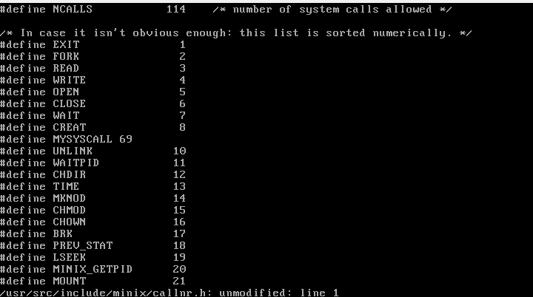

We then use :wq to exit the file and save the changes.
Step 2:
Then, we open the table.c file by writing vi /usr/src/servers/pm/table.c.
The table.c file contains a list of all system call functions used by the Process Manager. We add our own system call in this file so that the system knows which function to execute when our syscall number is called.

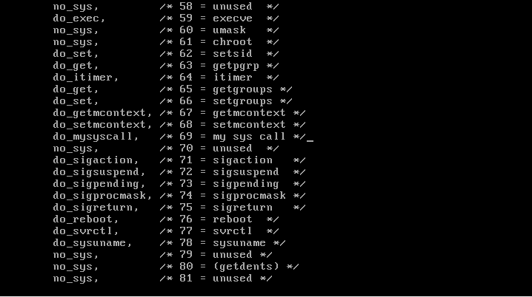

We then again use :wq to exit the file and save the changes.

Step 3:
Next, we open the proto.h file by typing vi /usr/src/servers/pm/proto.h.
proto.h contains function prototypes for all system call handler functions in the Process Manager. We search for this line: int do_getsetpriority(void); (inside /* misc.c */), and add int do_mysyscall(void); before it.

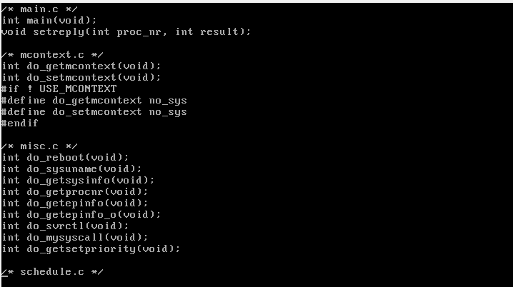

By declaring our new function in proto.h, we inform the compiler about its existence before it is actually defined in misc.c. Without this prototype, the compiler would not know the function’s name, return type, or parameters when compiling other files that reference it. Essentially, proto.h lists all the system call functions that the Process Manager provides, including their names, return types, and parameters, so the compiler knows how to use them before the functions are fully defined elsewhere.

Step 4:
This file contains the actual implementations of system call functions in the Process Manager. Here, we define our system call function do_mysyscall().
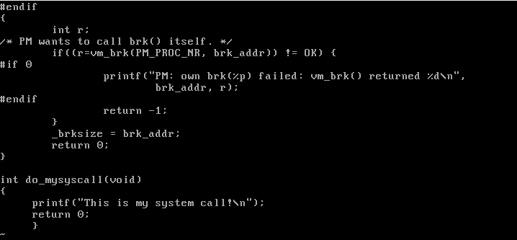

We add this function at the end of the misc.c file. We then save our file and exit by typing :wq.

Step 5:
Next, we navigate to the Process Manager directory by typing
cd /usr/src/servers/pm. This is where all the PM server source files, including misc.c, table.c, and proto.h, are located. We then type make to compile the Process Manager and check for any errors in our code. This step ensures that our new system call function and the changes in the other files are correctly compiled and integrated into the PM server before we proceed to use it.
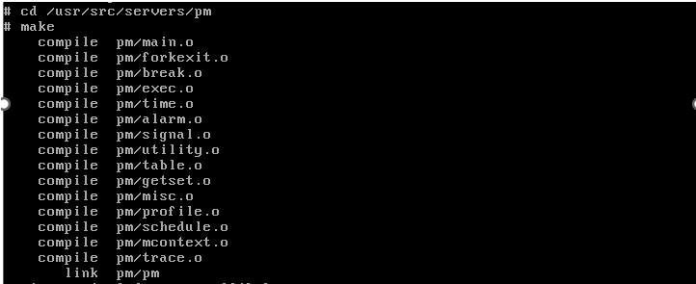

Step 6:
We then create the file mysyscalllib.h, by typing vi /usr/include/mysyscalllib.h.

We create the mysyscall() function in it, which is a user-level wrapper function. We create this to make it easy for user programs to use our system call without dealing with minix’s low-level message-passing mechanism.
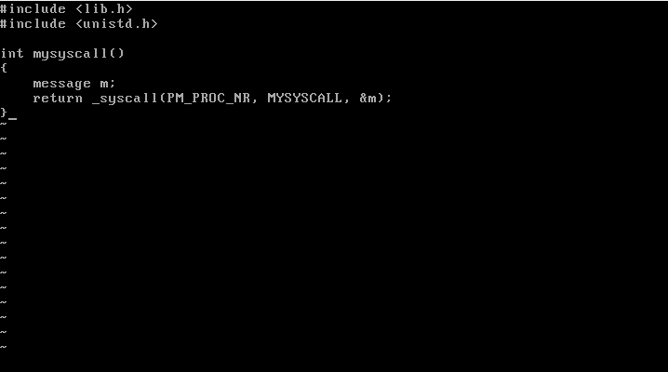

_syscall(PM_PROC_NR, MYSYSCALL, &m):
_syscall() is a library function provided by minix that sends a request from a user program to a server (like the Process Manager).
The arguments:
- PM_PROC_NR is a constant that identifies the Process Manager server. It tells _syscall() which server should handle the request.
- MYSYSCALL is the system call number we assigned (69). It tells the Process Manager which system call function to execute, in our case do_mysyscall().
- &m is a pointer to a message structure (message m). It is used to pass arguments to the system call and to receive results back from the server. Even if our system call doesn’t take any arguments, a message is still needed because minix system calls always communicate via messages.

Once again, save the file and exit by typing :wq.

Step 7:
We have to go to the release tools directory, so we type cd /usr/src/releasetools. We do this because we need to install the updated server into the running minix system.
Type make install. This copies the newly compiled Process Manager (PM) and any updated files to their proper locations in the system.
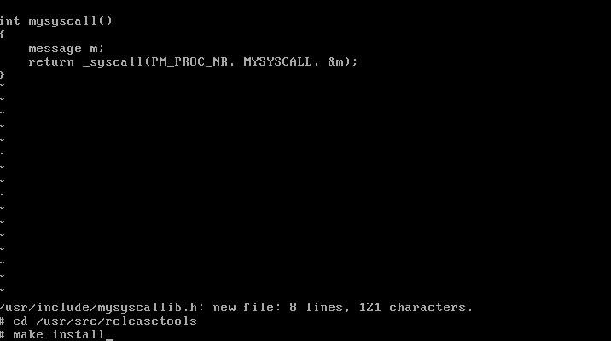

Then, type sync. It makes sure all the changes made by make install are safely written and nothing is lost when the system reboots.
Now, type reboot. This restarts the MINIX system so that the updated Process Manager is loaded into memory and becomes active. Without a reboot, the system would continue running the old version of PM, and our system call would not work.
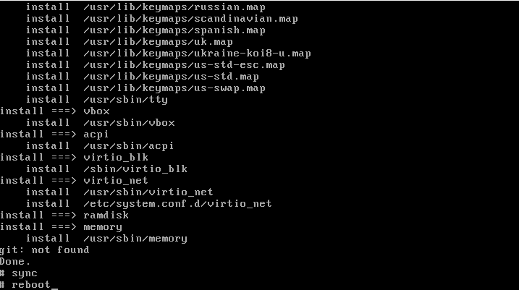

Step 8:
Now, we go to the “root” directory, by typing cd/root. We now create a new C file to test our system call by typing vi test1.c.

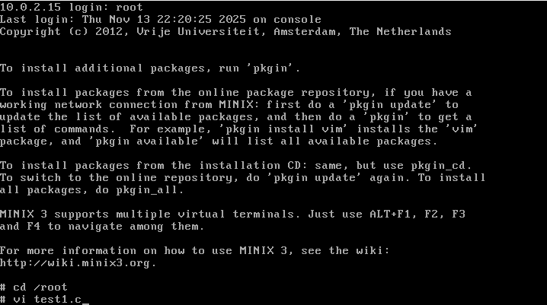
We then write the code to call our system call.
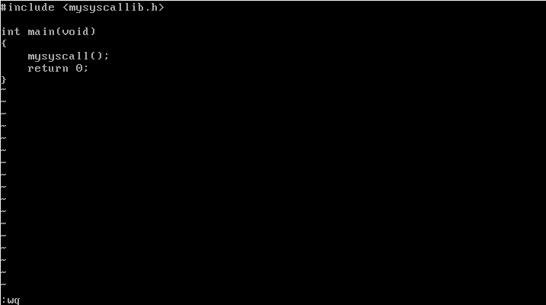

Then save the file and quit by typing :wq.
Next, we finally compile the file and run it.
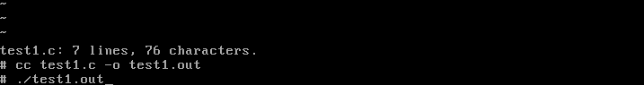

If everything, is working correctly, we get our output.
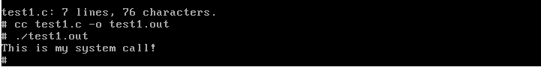

Hence, our system call has been implemented.
Pitfalls:
During development, two major pitfalls were encountered. First, the compiler failed due to resource shortage (memory and fork errors), requiring a VM RAM increase to 1GB to resolve the issue. Second, a compilation error during installation occurred because the system call was defined as MYSYSCALL 69 instead of #define MYSYSCALL 69. Once these issues were corrected, the PM server was successfully installed and the system was able to reboot.

References:
https://chatgpt.com/?oai-dm=1
Used chatgpt to understand: How does the kernel work in minix? What happens when we create a user-level wrapper function in minix? Why do we have to reboot minix?

